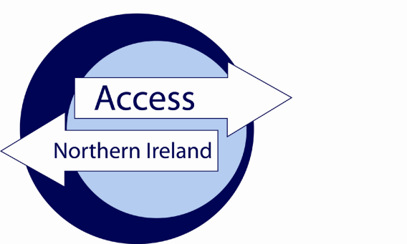

Your sport’s governing body needs certain information to process AccessNI applications online on your behalf.
Please follow the instructions below, sign the form and follow the validation process.

Applicant instructions

- Go to www.nidirect.gov.uk/apply-for-an-enhanced-check-through-a-registered-body

- Select the green button to Apply for an enhanced check through a registered body.

- Register your account by creating a user ID and password [keep these details safe as you will need them to track the progress of your case].

- Once you have successfully logged in, you will be taken to the on-line application.

- Enter the PIN number below at Step 1 of the form completion

9 | 3 | 6 | 1 | 7 | 7

- Complete the remainder of the form and click on confirm and proceed to finish the on-line process.

- You must note below the 10 digit AccessNI reference number in the boxes below:-

Application Reference

- Return this form to the person who asked you to complete the AccessNI application and present relevant identification as listed on the final page of this document

Identity validation

Three documents should be produced in the name of the applicant; one from Group 1 and two from Group 1 or 2a or 2b. At least one document must show the applicant’s current address. If this is not possible, then four documents from Group 2a and 2b should be produced, one of which being a birth certificate issued after the time of birth. One document must show the applicant’s current address.

Applicant details as they appear on the ID documentation provided:

Surname……………………. |  | First Name…………………………………Middle Name(s)……………………...
Date of Birth | : |  |  | / |  |  | /
Current postcode | :

Driving licence number……………………………… Passport number……………………………………..

National Insurance Number……………………………..

I confirm I have seen the original ID documentation as indicated on the attached sheet.

Date of ID check | : |  |  | / |  |  | /
Signed | : | ……………………………………………………………………….
Name (Capitals) | : | ……………………………………………………………………….

GROUP 1
 | Current passport (any nationality) |  | Original birth certificate (UK, Isle of Man or Channel Islands) issue at time of birth
 | Biometric Residence Permit (UK) |  | Original long form Irish birth certificate –issued at time of registration of birth (ROI)
 | Current driving licence (UK, ROI, Isle of Man, Channel Islands or any EEA country) |  | Adoption certificate (UK, Isle of Man or Channel Islands)
GROUP 2a
 | Birth certificate (UK, ROI, Isle of Man or Channel Islands) issued after time of birth |  | Electoral ID card (NI only)
 | Marriage/Civil Partnership Certificate (UK, ROI, Isle of Man or Channel Islands) |  | Current driving licence photocard (full or provisional) All countries outside the EEA
 | HM Forces ID card (UK) |  | Current driving licence (full or provisional paper version (if issued before 1998) (UK, Isle of Man, Channel Islands, EEA)
 | Firearms licence (UK, Channel Islands and Isle of Man) |  | Immigration document, visa or work permit (issued by a country outside the EEA – valid only if the applicant is working in the country that issued the document)
GROUP 2b
 | Mortgage Statement (UK, EEA) |  | Land and Property Services rates demand (NI only)
 | Financial statement, for example ISA, pension or endowment (UK) |  | Council tax statement (Great Britain, Channel Islands)
 | P45 or P60 statement (UK, Channel Islands)
Above documents must be issued within the last 12 months
 | Credit card statement (UK,EEA) |  | Bank or building society account opening confirmation letter (UK, EEA)
 | Bank or Building society statement (UK, EEA) |  | Utility bill (not mobile phone) (UK, EEA)
 | Bank or Building society statement (Outside EEA) (Branch must be in the country where the applicant lives and works) |  | Benefit statement, for example Child Benefit, Pension etc (UK, Channel Islands)
 | Central or local government, government agency, or local council document giving entitlement, for example from the Department for Work and Pensions, the Employment Service, HMRC (UK, Channel Islands)
Above documents must be issued within the last 3 months
 | EU National ID card |  | Cards carrying the PASS accreditation logo (UK, Isle of Man, Channel Islands)
 | 60+ or Senior (65+) SmartPass issued by Translink (NI) |  | Letter from head teacher or further education college principal (UK for 16 -19 year olds in full time education – only used in exceptional circumstances if other documents cannot be provided)
 | Link card issued by Translink (NI) |  | Letter of sponsorship from future employment provider or voluntary organization (Non UK or non-EEA only for applicants residing outside UK at time of application)
Above documents must be valid at the time of checking

This is the 10 digit case reference number provided on the confirmation page(Step 12) and email when the applicant completes their details on the AccessNI on-line system.

